Infusing First Nations politics in an academic English course at UBC Vantage College
Jennifer Walsh Marr, BCCIE Summer Seminar 2016
An exploration of the rationale and process of developing EAP materials for Poli Sci 100 that draws on research articles about First Nations political activism for academic discourse analysis. Student reflections on their understanding of First Nations issues and pertinent language features of Political Science research articles and instructor reflection on revisions for future offerings.

Course outline:

VANT 140: Poli Sci 100

The focus of this class is on the academic discourse of Political Science, and is one part of VANT 140. There is ONE course grade for all three VANT 140 streams (ie including VANT 140 PSYC & VANT 140 GEOG). Your participation and performance in my class will be included in your overall VANT 140 grade and therefore your UBC transcript.
I am in communication and collaboration with my colleagues Amber Shaw (VANT 140 GEOG) and Brett Todd (VANT 140 PSYC). The focus of our classes may be similar or different week to week, but all are designed to support the learning objectives of VANT 140.
Course Description:
This section of VANT 140 focuses on the use of language in the discipline of Political Science. I will draw from texts in this discipline to help:
- you recognize
  - key terms and ideas in Political Science
  - how ideas are organized, supported and developed in Political Science
  - features of explanation in Political Science
- you analyze how and which participants and processes are represented in Political Science
- you represent ideas in appropriate paraphrases
- you understand and appropriately respond to Political Science examination tasks
- facilitate your reflection on your learning and attitude towards
  - the language features of Political Science
  - First Nations peoples in Canada and in other parts of the world
One of my major goals is to enable you to become independent undergraduate scholars. I have designed my lessons and activities to help you look for, recognize and apply patterns and strategies to your work. I want to share tools that give you confidence to analyze not only what is being said, but how and why in that way.
Success in university depends on regular and conscientious review of and engagement with course materials.
We will be focusing our language work on the following five key texts. It is your responsibility to access and read these texts before class. Will we return to several of the texts throughout the term, analyzing different features.
Belton, K. A., (2010). From Cyberspace to Offline Communities: Indigenous Peoples and Global Connectivity. Alternatives: Global, Local, Political. Indigenous Politics: Migration, Citizenship, Cyberspace. 35 (3), 193-215. Retrieved from http://www.jstor.org/stable/41319257
Iyall Smith, K. E., (2008). Comparing Stage and International Protections of Indigenous Peoples' Human Rights. American Behavioral Scientist, 51 (2), 1817-1835, doi: 10.1177/0002764208318933
Morris, A., (2014). Twenty-First-Century Debt Collectors: Idle No More Combats a Five-Hundred-Year-Old Debt. WSQ: Women's Studies Quarterly, 42 (1&2) 242-256, doi: 10.1353/wsq.2014.0025
Woons, M. (2013). The “Idle No More” movement and global indifference to Indigenous nationalism. AlterNative: An International Journal of Indigenous Peoples, 9(2).
Wotherspoon, T., & Hansen, J., (2013). The "Idle No More" Movement: Paradoxes of First Nations Inclusion in the Canadian Context. Social Inclusion, 1 (1), 21-36.
Dr. Peterson will reference key disciplinary ideas from these articles and relate them to themes in the lectures and Poli Sci textbook.
Planned Scope & Sequence for Term 1:
Week/dates | Focus | Formal Assessments | Required Readings & location
1  Sept 7-11 | Jumpstart
2  Sept 14-18 | Course Introduction, Reflection |  | Wotherspoon & Hansen  *posted as pdf on Connect
3  Sept 21-25 | Vocabulary building |  | Belton  *posted as pdf on Connect
4
Sept 28- Oct 2
5  Oct 5-9 |  | Vocabulary test
6  Oct 12-16 | Organizational features of texts |  | Morris  *available through UBC library
7  Oct 19-23 |  | Information Ordering test | Woons  *available through UBC library
8  Oct 26-30 | Detailed features of texts: explanation, passive voice
9
Nov 2-6
10  Nov 9-13 | Paraphrasing |  | Iyall Smith  *available through UBC library
11
Nov 16-20
12  Nov 23-27 | Reflection | Reflection
13  Nov 30- Dec 4 | Test as text
In addition to these more formal assessments, there will be pop quizzes, homework, homework checks and other participatory tasks from time to time. These will not only count towards your participation grade, but more important, support your ongoing engagement and success in VANT 140.

Preparation for Reflection:
What I Know about First Nations:
What does First Nation mean? Do you know any synonyms?
What are the demographics of Canada? What is the political climate in Canada? How does Canada treat its peoples?
What I Wonder about First Nations:
Be as specific as you can.
What I Know about Academic discourse in Political Science:
What are the language features of English used in Political Science?
Have you noticed anything in your first few readings & lectures?
What I Wonder Academic discourse in Political Science:
Be as specific as you can.

Morphology:
Colloborative, Inductive reasoning task:

Text term | Related words | Morphemes | Meaning
nationhood | national, international, innate, native | nat-
 | domination, transfusion | -tion (-sion)
 | childhood, manhood, neighbourhood | -hood

Text term | Related words | Morphemes | Meaning
delegate | deduct, decrease, delude |  | away from, down (send out)
 | legal, legislate |  | commission, law, contract

Text term | Related words | Morphemes | Meaning
equitable |  | equi- | equal, identical in amount
 |  | -able(-ible) | is, can be

Causation: Explicit & Implicit
Intro Task: circle the language features that show cause:
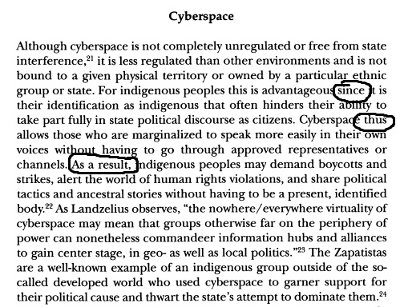
Belton, 2010 pg 197
Extension: Comprehension questions:
- Why is it beneficial to Indigenous peoples that cyberspace is essentially stateless?
- What hinders Indigenous peoples’ full participation in politics?
  - Why do you think this is? (this is an opinion question not in the text, but based on your understanding of politics and power)
- How does cyberspace enable Indigenous people to fully participate in politics?
- What does participation in politics allow Indigenous people to do?
- What feature of the internet allows Indigenous people to move from the periphery to the centre of politics?
- How do the Zapatistas use the internet to their benefit?

What is the language used to show these causes and effects in the questions above?
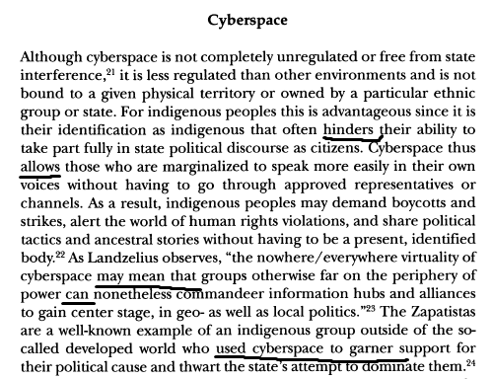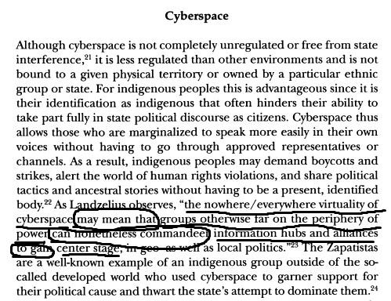

Passive Voice
Notes on Function:
Writers may use the passive voice for a few different reasons:
- Prioritizing participants: The actor (active subject) is not really important. Instead, the author wants to focus on the goal (active object).
- Prioritizing participants: the actor is omitted:
  - because it is unknown or
  - to avoid highlighting responsibility.
- Thematic development: the goal is known information and so put into theme position (starting point of the clause).
- Thematic development: the author wants to further develop a topic (the rheme/new information from an earlier clause).
Any and all of these reasons can impact the positioning of the participants, the author(s) and the readers.

Task 1: Compare & contrast the meaning & positioning of individuals in these two excerpts (Belton, 2010, pg 206):
Text A:
Indigenous peoples are making connections and forcing others to contend with them in various locales and in multiple ways. The number of workshops, conventions, and meetings that indigenous groups have put together to inform themselves of issues affecting them is remarkable, and their ability to learn the language of international fora is commendable, as is their ability to persuade institutions to consider indigenous issues. In addition to the PFII and WGIP sessions, indigenous peoples take part in the meetings of the Commission on Human Rights, the World Intellectual Property Organization and the Commission on the Status of Women, and they participated in the Fourth World Conference on Women and the World Conference on Human Rights, among other events.
Text B:
Interactions and connections are being made in various locales and in multiple ways. A remarkable number of workshops, conventions, and meetings have been put together to inform indigenous peoples of issues affecting them, and it is commendable that they have been taught the language of international fora and been able to persuade institutions to consider indigenous issues. In addition to the PFII and WGIP sessions, indigenous peoples have been admitted in the meetings of the Commission on Human Rights, the World Intellectual Property Organization and the Commission on the Status of Women, and they have been included in the Fourth World Conference on Women and the World Conference on Human Rights, among other events.
Consider each of the following:

Content
Organization
Interpersonal Positioning
Grammar
Task 2: In these excerpts, identify which participants are present, and which ones are omitted:
“…treaty rights are being violated by C-45 because the reserve lands were set aside for the exclusive use and benefit of band members only, “so the concept of surrendering those lands conditionally or unconditionally is something that takes away from the collective use and benefit . . . especially if the integrity is not maintained. At a minimum, it requires the consent of First Nations to agree to this legislative change, and that’s a legal requirement by the Supreme Court of Canada,” according to Palmater (2013). These unilateral changes to the legal functioning and decision making of First Nations were made without their consent, and so Idle No More continues to fight against this abrogation of treaty rights with protests and road blockades across Canada. “
(Morris, 2014, pg. 247)
Task 3: Note how the use of the passive voice is different here than in earlier examples:
“Comack observes, "Aboriginal men are regularly stopped by police, sometimes on a weekly basis, and asked to account for themselves" ([36], p. 30 210).”
(Wotherspoon & Hansen, 2013, pg. 30-31)
Task 4: extra practice: Why might the author have used the passive voice? What impacts does the use of passive voice have on meaning?
“The movement was originally motivated by the existence and implementation of Bill C-45, another in a long line of omnibus budget bills that amends the Indian Act, which is widely considered by many Indigenous peoples to be an exclusionary, assimilationist, and deeply discriminatory piece of legislation that is particularly hard on Indigenous women.”
(Morris, 2014, pg. 245)
Paraphrasing
Warm up Discussion questions:
As university students, why do you paraphrase?
Why do you think paraphrasing is valued in academic discourse?
Is paraphrasing easy or difficult for you? Why?
What makes a good paraphrase?
What strategies or steps do you take when you paraphrase?
Share your answers and notes with other students.
Analysis task:
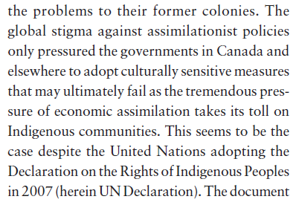
What prompted the Canadian government to “adopt culturally sensitive” policies?
stigma/political pressure against assimilationist policies

What is the author’s prediction about these policies?
”may ultimately fail” due to “economic assimilation”_

Woons, 2013, pg. 174
Paraphrase: International pressure prompted Canada and other governments to shift policies towards being more respectful of Indigenous culture. However, Woons, (2013) predicts these measures cannot necessarily protect Indigenous communities from being subsumed by economic factors.
What changes were made from the original answers/notes from the text and the paraphrase?
Reflection: What I learned about First Nations & Academic discourse in Political Science
Describe your understanding of First Nations in week 2 (you should reference the writing you did in week 2 of the course).
My understanding in the second week was narrower than now. I did not know that First Nations are an active group who defends its rights and pursues for justice. Therefore, I could think that my scope about their situation was quite limited. In my knowledge, they were a kind of passive persons who lived in peace with the government. That idea gave me a false reality of those peoples and the Canadian government policies regarding them. In thought that in Canada there were just the typical problems as that many countries face.
Explain how your understanding of First Nations has or hasn't changed over the last 10 weeks of the course.
Nowadays, I am aware that First Nations suffered great genocides, they were almost annihilated by discriminatory policies. Moreover, that discrimination persists until now. Regardless of that First Nations stand up and face those policies. They are showing up all the injustice they have suffered from the colonization. I am conscious that they are not passive subjects any more, they started to leave people listen to their voice and people are eager to help them. They want people to know that better policies regarding them and the environment can be created. However, for the Canadian government policies regarding economic stability are more important that its people and their homelands.
“I have learnt about how their title as Indigenous people may infact be a threat to their sovereignity and peace. Through learning about their movement 'Idle No More', and its importance as a civil society campaign for equal rights and recognition in the United Nations I see the impact it has on the future generations of First Nations and even non First Nations.”
Identify, describe and explain the relevance of a feature of political science discourse you have worked with this semester.
The feature of political science discourse I want to describe and explain is the functions active and passive voices. One of the major functions of passive voice is to hide the participants. For example "the bill C-45 was violated in...", the people who violated the laws were not mentioned in the sentence. When newspapers and social medias used the passive voices in this way, they are trying to remove the social responsibilities of participants.When we read sentences written in passive voices, we need to critically think who are the participants.
“…there are also various grammatical structures, in the lesson of passive voice and active voice, the different use of language features can change the interpersonal positioning and how the author want to represent to readers. Because we can feel the positive and negative thoughts about one historical event, the different language features and grammatical structures can make readers get different direction of the understanding, on the other hand, it's also a warning that we need to think about the questions with critical perspectives.”

I learn several language feature in this course. I think the most relevant and important one is the skill of paraphrasing the text in the article. I think this is a important skill to learn English. I learn Paraphrase is important because the way how a sentence is form can make the meaning very different. For example, Jennifer gave us a example of text about aboriginal people's evaluation in passive voice. In passive voice, the actions is more important than the aboriginal people. If we paraphrase it in active voice, it would make great difference as audience would pay attention to aboriginal people. Active voice and passive voice can make change the emotions from softer to stronger. In addition, sometimes we paraphrase it in passive way to let audience ignore who take the actions. For example, aboriginal people's land were taken. In this sentences, we know Canadian government took their land, but audiences would less focus on it. Another reason to learn paraphrase is to prevent plagerism. As students, we want to make our writing professional and not copying the exact words from original text. I also learn the good paraphrase means to write it by using different word choices, but the exactly same meaning. I also learn we still need to cite the paragraph even we do paraphrases because the idea is still from author. It is a important skill for students to learn in order to write a good essays.

“A political Science discourse feature I have worked with and particularly found very helpful is the use of passive voice in interpersonal positioning. It is generally a tool used in academic writing or even in literal works by writers so as to dismiss the relevance of the actor. To be more specific; this maybe because the author wants to remove blame from an actor, he has no certainity over who exactly did what (insufficient information), or the author generally wants the information to be actorless (affiliation to the real instigator of the problem)…. Because of its ability to somehow control how the reader perceives and understands the literature, the author might do this intentionally to remove any criticism from the real actor. Why is this relevant to my writing? Political Science is not like a mathematical problem. It is easy to get lost in trying to write something that does not necessarily threaten me the writer and the existing literature. So it allows to be careful and safe yet somehow still show the right content of the reader. It allows me to position my writing to the intended readers, thereby not in any way offending or misrepresenting information that might already be biased. Already in my writing, I look foward to using it more often.”

Further Resources
Indigenizing the academy: What some universities are doing to weave indigenous peoples, cultures and knowledge into the fabric of their campuses. http://www.universityaffairs.ca/features/feature-article/indigenizing-the-academy/
“On whose land we sit”: the difference in Indigenous engagement between UBCO and UBC Vancouver: http://ubyssey.ca/news/on-whose-land-we-sit-the-difference-in-indigenous-engagement-between-ubco-and-ubc-vancouver/?platform=hootsuite
Time and Place at UBC: Our Histories and Relations: http://timeandplace.ubc.ca/
UBC’s Aboriginal Strategic Plan: http://aboriginal.ubc.ca/strategic-plan/
UBC Centre for Teaching & Learning Aboriginal Initiatives: http://ctlt.ubc.ca/programs/aboriginal-initiatives/
Words First: An Evolving Terminology Relating to Aboriginal Peoples in Canada: http://publications.gc.ca/collections/Collection/R2-236-2002E.pdf

References
Airey, J. (2016). EAP, EMI or CLIL? In S. Philip & K. Hyland (Eds.). The Routledge Handbook of English for Academic Purposes. Routledge.
Belton, K. A., (2010). From Cyberspace to Offline Communities: Indigenous Peoples and Global Connectivity. Alternatives: Global, Local, Political. Indigenous Politics: Migration, Citizenship, Cyberspace. 35 (3), 193-215. Retrieved from http://www.jstor.org/stable/41319257
Canagarajah, S. (2006). A Writing Pedagogy of Shuttling Between Languages. College English, 68 (6).
Iyall Smith, K. E., (2008). Comparing Stage and International Protections of Indigenous Peoples' Human Rights. American Behavioral Scientist, 51 (2), 1817-1835, doi: 10.1177/0002764208318933
Kohonen, V. (2000). Student reflection in portfolio assessment: making language learning more visible. Babylonia, 1(2000), 13-16.
Kubota, R. (2003). Critical Content-Based Instruction in the Foreign Language Classroom: Critical Issues for Implementation. In B. Norton & K. Toohey (Eds). Critical Pedagogies and Language Learning. Cambridge University Press.
Moore, T. (2007) The Processes’ of Learning: On the use of Halliday’s transitivity in academic skills advising. Arts & Humanities in Higher Education. 6 (1) 50-73.
Morris, A., (2014). Twenty-First-Century Debt Collectors: Idle No More Combats a Five-Hundred-Year-Old Debt. WSQ: Women's Studies Quarterly, 42 (1&2) 242-256, doi: 10.1353/wsq.2014.0025
Spack, R. (2004). Strangers in academia: The experiences of faculty and ESOL students across the curriculum. In V. Zamel & R. Spack (Eds.), Crossing the curriculum: Multilingual learners in college classrooms (pp. 3-17). Mahwah, NJ: Lawrence Erlbaum Associates.
Truth and Reconciliation Commission of Canada . Honouring the Truth, Reconciling for the Future Summary of the Final Report of the Truth and Reconciliation Commission of Canada, 2015. Available from www.trc.ca/websites/trcinstitution/File/2015/Findings/Exec_Summary_2015_05_31_web_o.pdf
Woons, M. (2013). The “Idle No More” movement and global indifference to Indigenous nationalism. AlterNative: An International Journal of Indigenous Peoples, 9(2).
Wotherspoon, T., & Hansen, J., (2013). The "Idle No More" Movement: Paradoxes of First Nations Inclusion in the Canadian Context. Social Inclusion, 1 (1), 21-36.

email: jennifer.walshmarr@ubc.ca
twitter: @MarrWalsh

