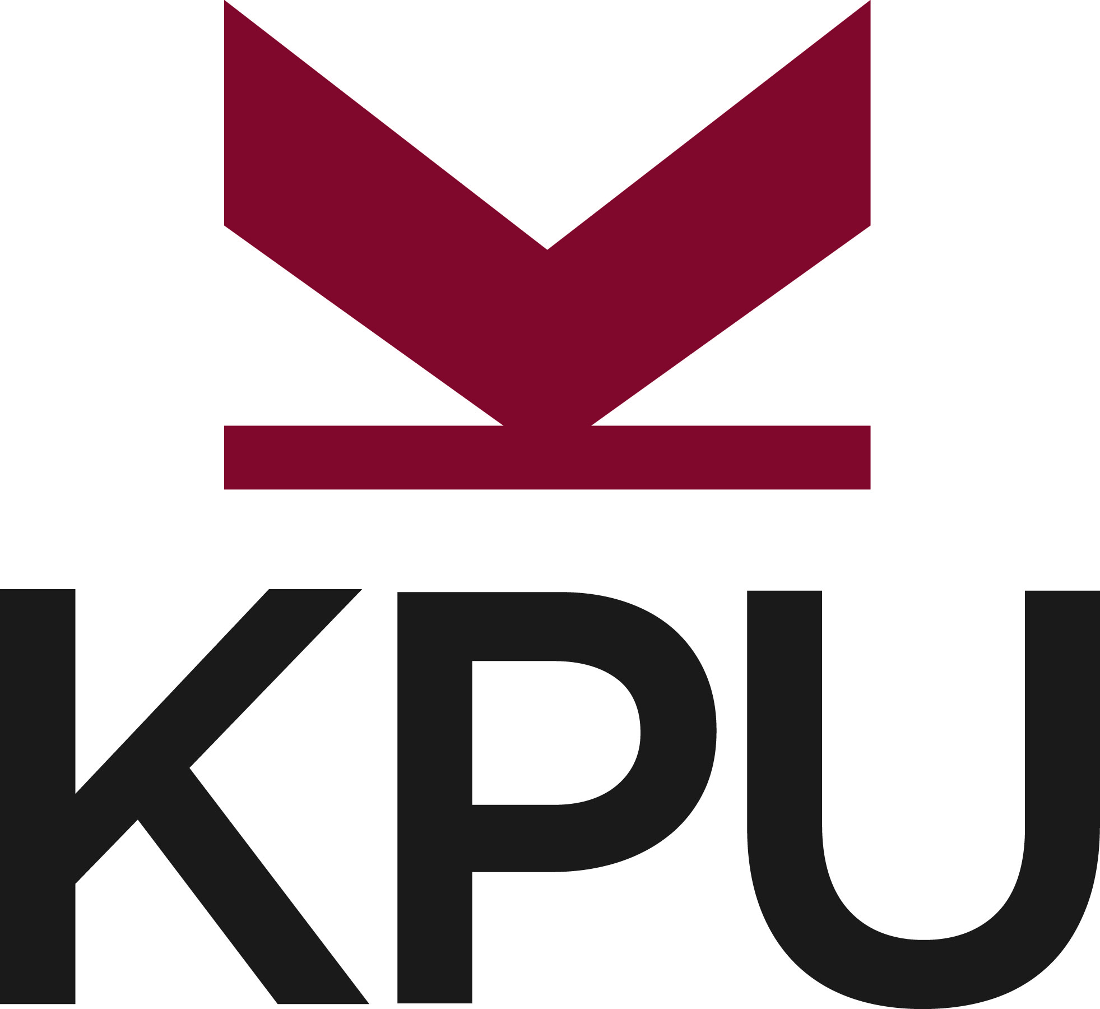

KPU offers all learners opportunities to achieve success in a diverse range of programs that blend theory and practice, critical understanding, and social and ethical awareness necessary for good citizenship and rewarding careers.

GLOBAL PARTNERSHIP ADVISOR, EMERGING MARKETS Competition Number 17-33A

Kwantlen Polytechnic University has an exciting opportunity for global partnership advisor to provide guidance and advice to international students within the KPU International department. In this role, the successful candidate will advise and support students in developing educational plans, achieving career and educational goals, and helping students understand and ensure compliance with the requirements of their study permits as defined by the Canadian Immigration and Refugee Protection Act. Among other tasks, s/he will develop and implement strategies to communicate the external partners and support students coming from partnership programs; coordinate special events, such as open houses; develop and maintain web and printed information resources; and respond to enquiries regarding KPU programs, services, and procedures.

The successful candidate must have successfully completed an undergraduate degree and possess minimum of two years of employment in a comparable, international-related position, preferably in post-secondary education. S/he must possess excellent communication skills in English, both written and verbal, as well as the ability to speak and write fluently in at least one additional language utilized within KPU’s targeted markets (Russian, Spanish, Portuguese, French, and Farsi). KPU International is searching for a candidate with a proven ability to exercise a high level of initiative and responsibility as well as the capacity to work independently and meet project deadlines.

This is a full time one year position with likelihood of extension.

Please forward your resume, including photocopies of post secondary transcripts, quoting competition number 17-33A to: employ@kpu.ca

All qualified candidates are encouraged to apply; however Canadians and permanent residents will be given priority.

